User Manual

(Machine Problem 2)

Secant Method

1. Find the “Secant Method” executable file which is located at the Machine Problem 1 folder (Machine Problem 3 > Executables > Secant Method). Then, run the Program and just wait for a few seconds after the program has been loaded.

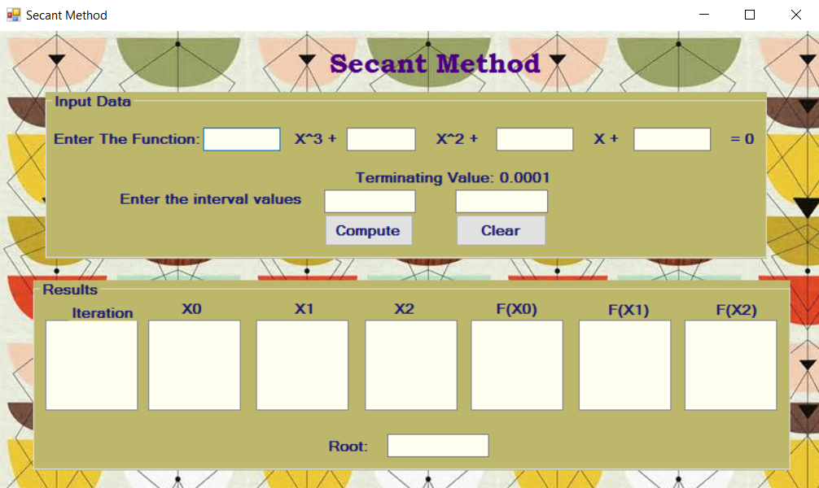

2. The user will then input the values for the coefficients of the function and its interval values.

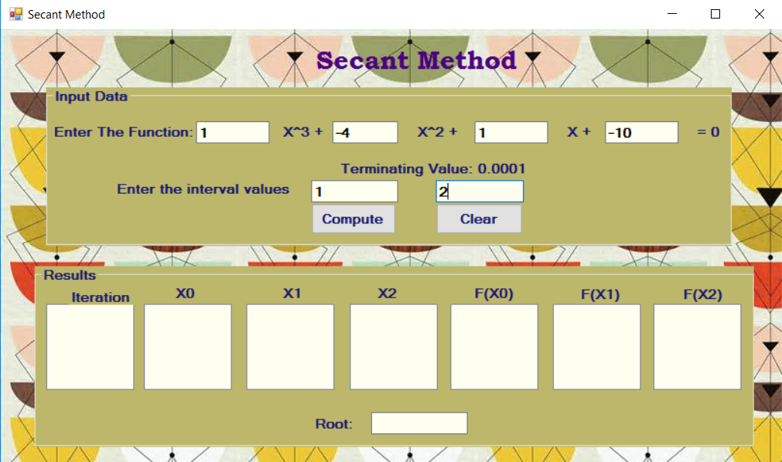

3. Click the “Compute” button. In the results window, the user will then see the tabulated results of the iterations.

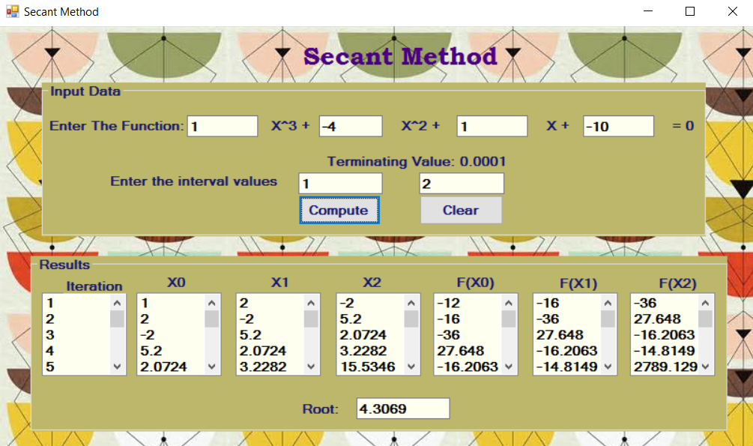

4. To solve for another set of equations just click the “Clear” button and repeat the process.